NVD Dealer Tracking App
User’s Manual

Contents

NVD Dealer Tracking App (Mobile Version) 2
Downloading the App & Pairing Users 2
Login 2
Adding Users 3
Functionality 5
Track & Trace 5
Query Vehicles with NVD 6
Arrange Self Collects 8
Add Services 9
NVD Dealer Tracking App (Desktop Version) 12
Downloading the App & Pairing Users 12
Login 12
Adding Users 13
Functionality 15
Track & Trace 15
Query Vehicles with NVD 16
Arrange Self Collects 18
Add Services 19

NVD Dealer Tracking App (Mobile Version)

Downloading the App & Pairing Users

The app can be downloaded from both the Apple App Store and Google Play Store.
Search for “NVD Dealer App”.

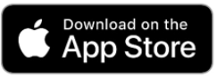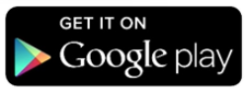

Login

To get your login details please contact the below:
- tq@nvd.ie
Login using your unique details provided by NVD
- Your email
- Password provided by NVD
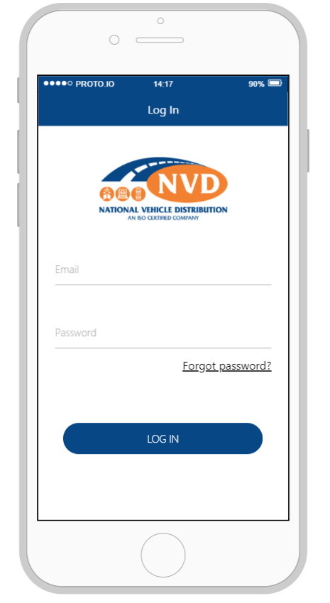

Adding Users

The master user will have the ability to add / remove users paired.

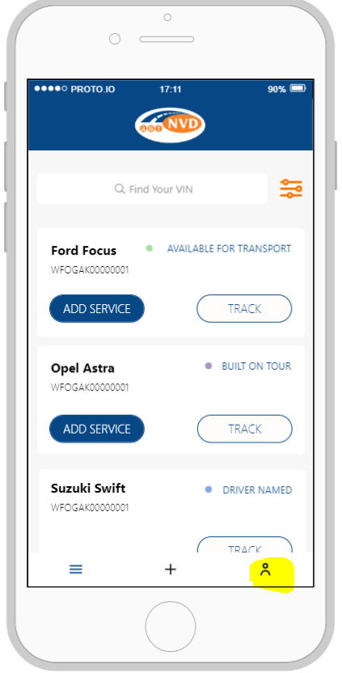
Simply login and click the icon highlighted
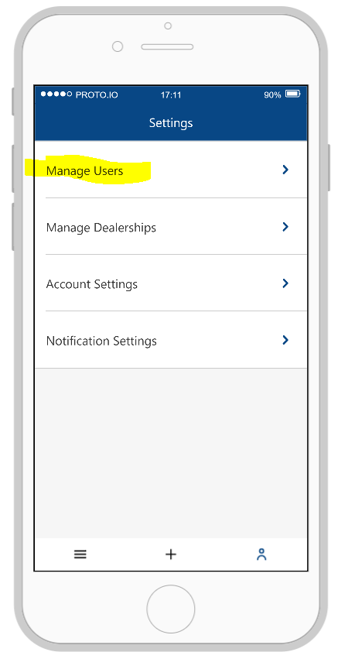
Click Manage Users

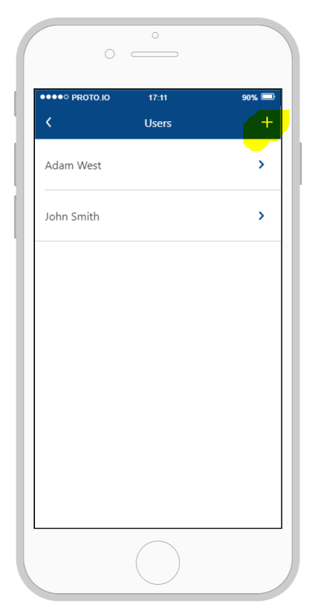
Click the “+” icon

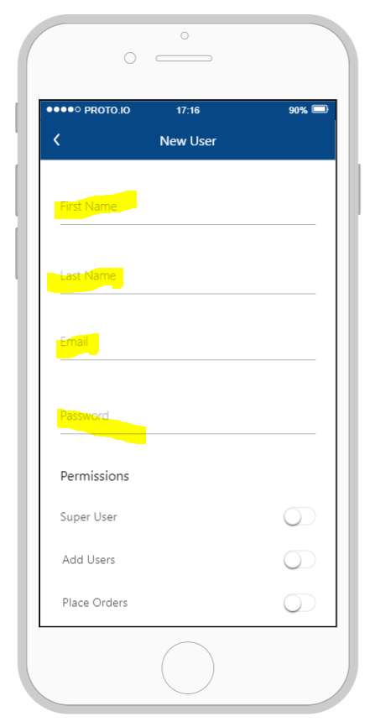
Enter the relevant details

Functionality

Track & Trace

Track and trace your vehicles in real time. The app will provide you with status updates, detailing where your car is in the delivery cycle right from the time of order to delivery.
Status Updates Include –
- In Services
  - Not available for transport as vehicle requires a work order to be completed
- Available for transport
  - Vehicle allocated and available for NVD to plan delivery
- Built onto a tour
  - Vehicle has been added to a load for delivery
- Driver Named
  - A driver has been assigned to deliver the tour
- In Transit
  - Vehicle in transit
- Delivered
  - Vehicle delivered
The app will also provide an Estimated Time of Arrival (As shown below)
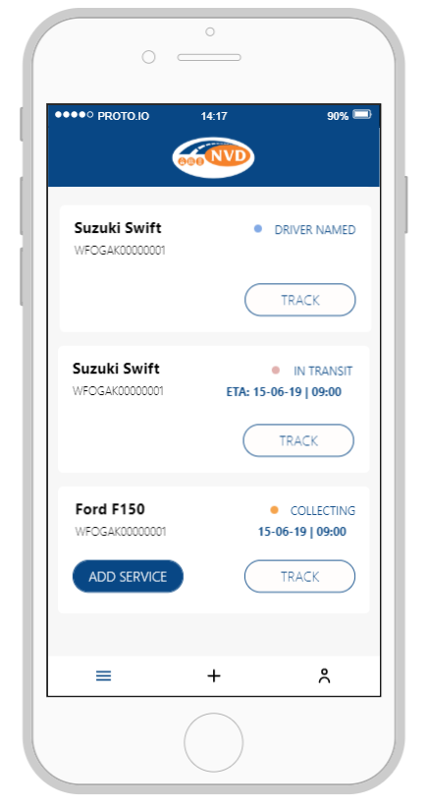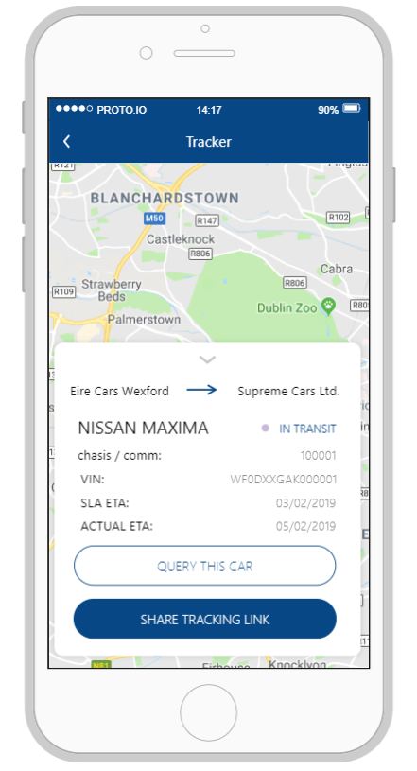

Query Vehicles with NVD

The Dealer Tracking App also allows you to contact our Customer Service team directly from the app.

One Vehicle

Simply click on your nominated vehicle and select “Query This Car”. Enter your query into the text box and our Customer Service team will reply to you via email.
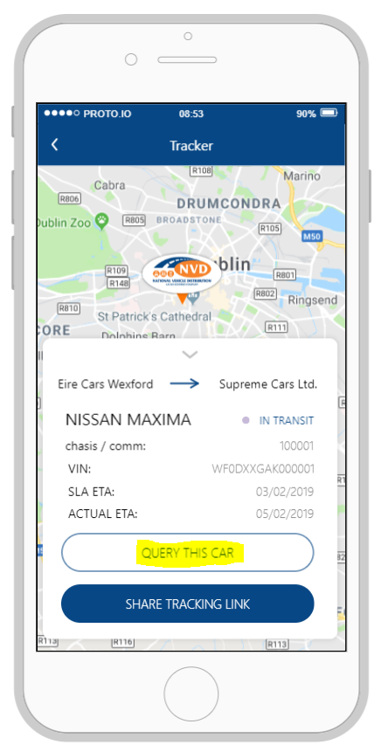
Simply click on your nominated vehicle and select “Query This Car”. Enter your query into the text box and our Customer Service team will reply to you via email.

Query vehicles in bulk

If you have queries on numerous vehicles you may also contact us using the “batch query” function.
Simply click on the “+” below and “Query Cars”.
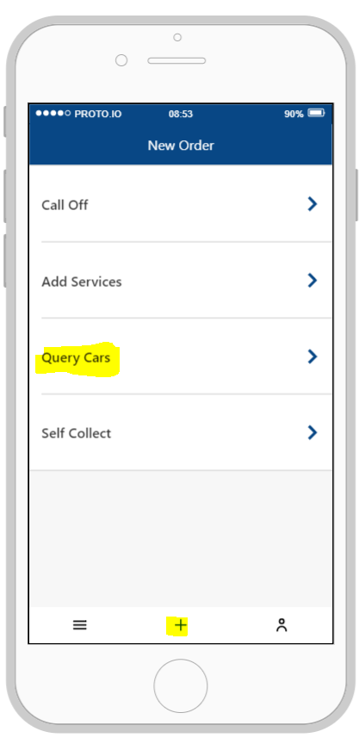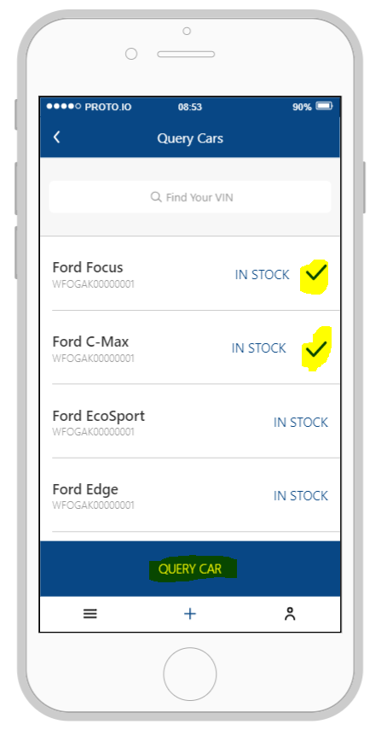
Select the vehicles you wish to query and enter your query into the text box and our Customer Service team will reply to you via email.

Arrange Self Collects

The Dealer Tracking App allows you as the dealer to arrange dealer self collects at pre agreed times.
Please be aware that collection slots are limited and are on a first come first serve basis.

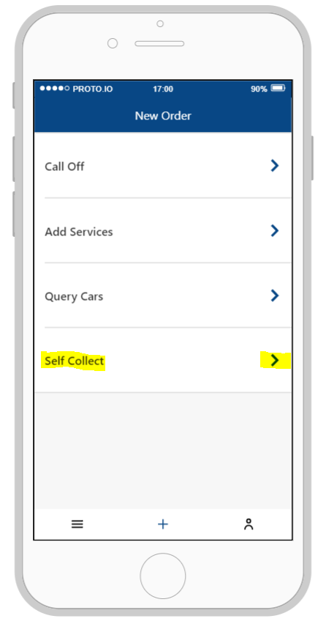
Select the “self-collect function. Click on the car you wish to collect

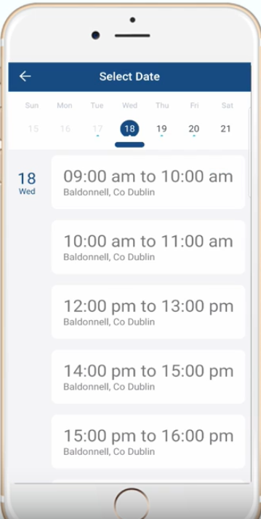
Select the time which you wish to collect.
NOTE – if collection slots are full the next available time will be only be available

Add Services

Order services via the Dealer Tracking App.

One Vehicle

Select the vehicle you wish to add the service to. Click “Add Service”.

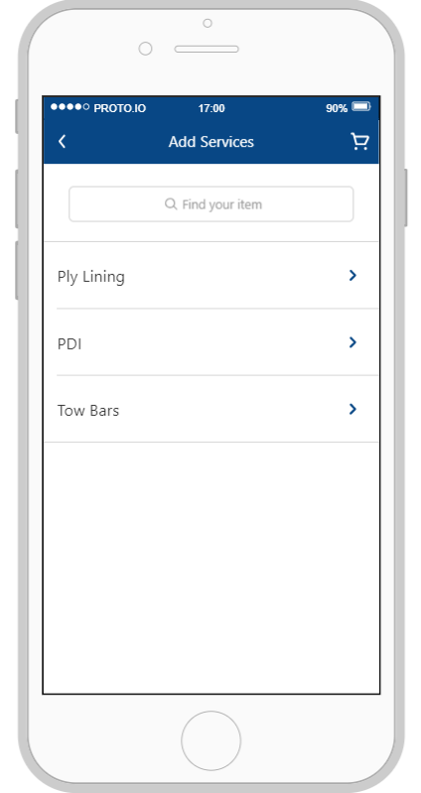
Select the service you wish to add from the list provided.
Note – this will vary depending on agreements.

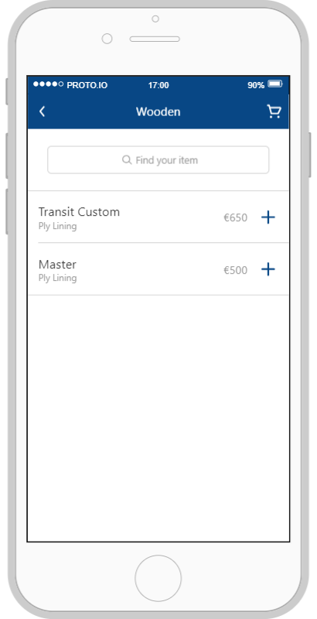
Click the “+” symbol. This will create the service and generate a charge accordingly
Note – if you are set up on Direct Debit with NVD the charge will be taken via this method. If you are not you will be prompted to enter credit card detail as payment is required before the service(‘s) are completed.

Order service in batch

The app also allows you to order services for numerous vehicles at the same time.
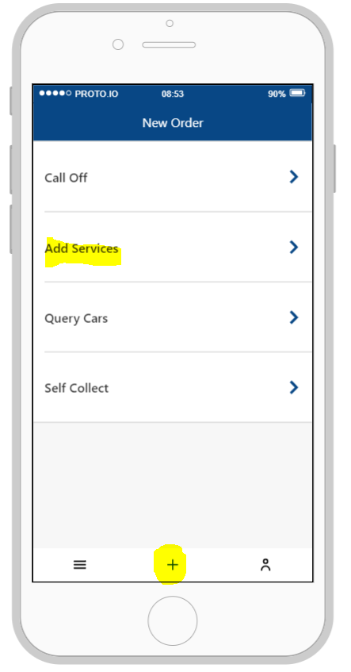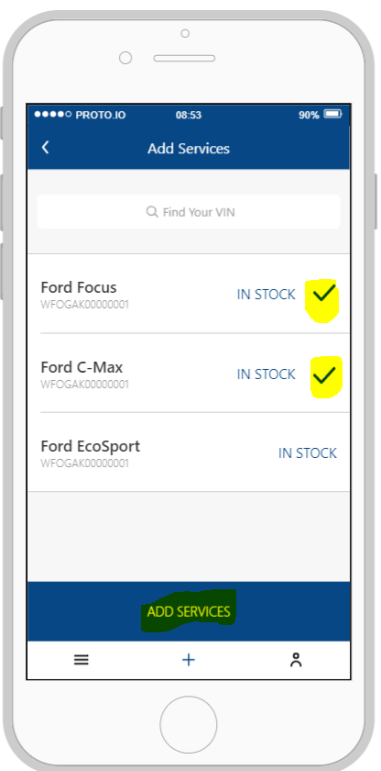
Click the “+” symbol and “Add Services”
Select the vehicles which you would like to add services to.
The follow the instruction laid out above

NVD Dealer Tracking App (Desktop Version)

Downloading the App & Pairing Users

Login

Link to desktop version –
- https://dealer.vehiclelogistics.ie/dealer
To get your login details please contact the below:
- tq@nvd.ie
Login using your unique details provided by NVD
- Your email
- Password provided by NVD
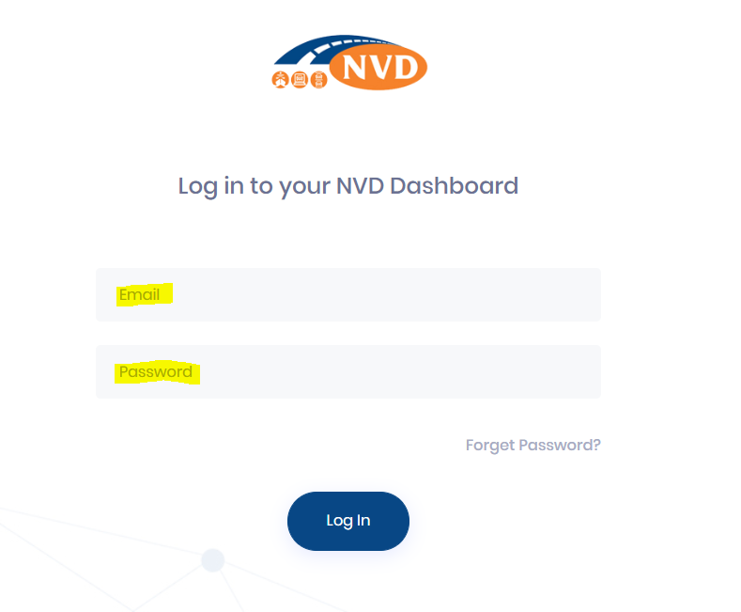

Adding Users

The master user will have the ability to add / remove users paired.
From the dashboard please select the highlighted tile.

Select “My Users”
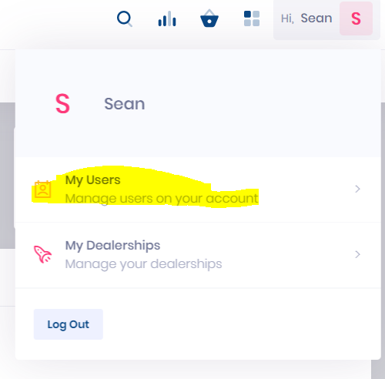

Select “New User”
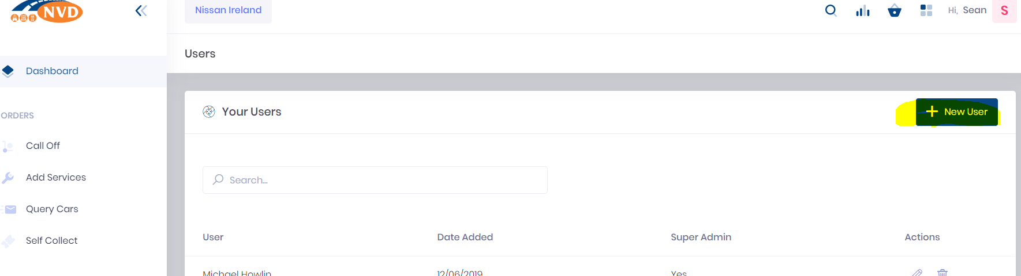

Complete the relevant inputs
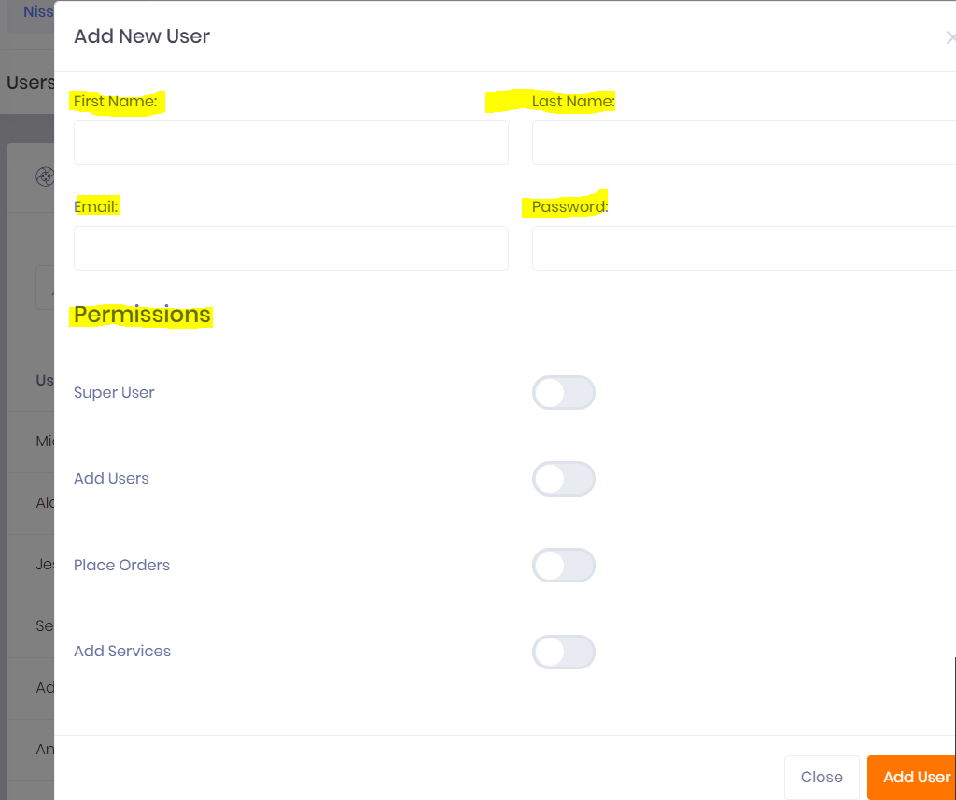

Functionality

Track & Trace

Track and trace your vehicles in real time. The app will provide you with status updates, detailing where your car is in the delivery cycle right from the time of order to delivery.
Status Updates Include –
- In Services
  - Not available for transport as vehicle requires a work order to be completed
- Available for transport
  - Vehicle allocated and available for NVD to plan delivery
- Built onto a tour
  - Vehicle has been added to a load for delivery
- Driver Named
  - A driver has been assigned to deliver the tour
- In Transit
  - Vehicle in transit
- Delivered
  - Vehicle delivered
The app will also provide an Estimated Time of Arrival (As shown below)
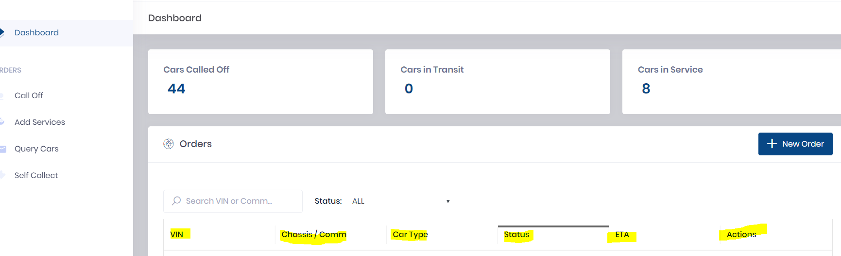

Query Vehicles with NVD

The Dealer Tracking App also allows you to contact our Customer Service team directly from the app.

One Vehicle

Simply click on your nominated vehicle and click on the highlighted icon below. Enter your query into the text box and our Customer Service team will reply to you via email.
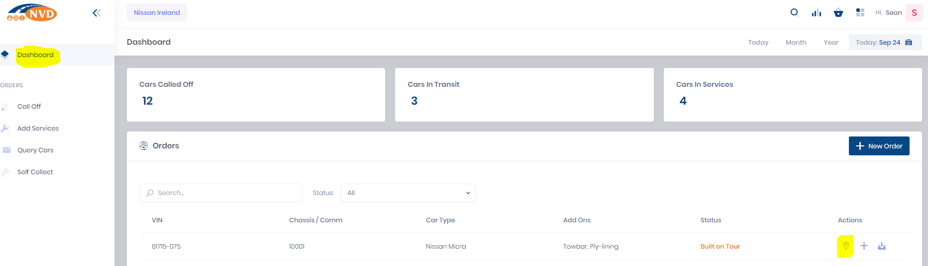
Click on “Query Car”.
Enter your query into the text box and our Customer Service team will reply to you via email.
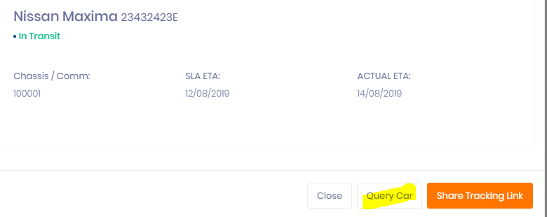

Query vehicles in bulk

If you have queries on numerous vehicles you may also contact us using the “batch query” function.
Simply click on the “Query Cars”.
Select the vehicles which you want to ask a question on.
Click “Query Selected”.
Enter your query into the text box and our Customer Service team will reply to you via email.
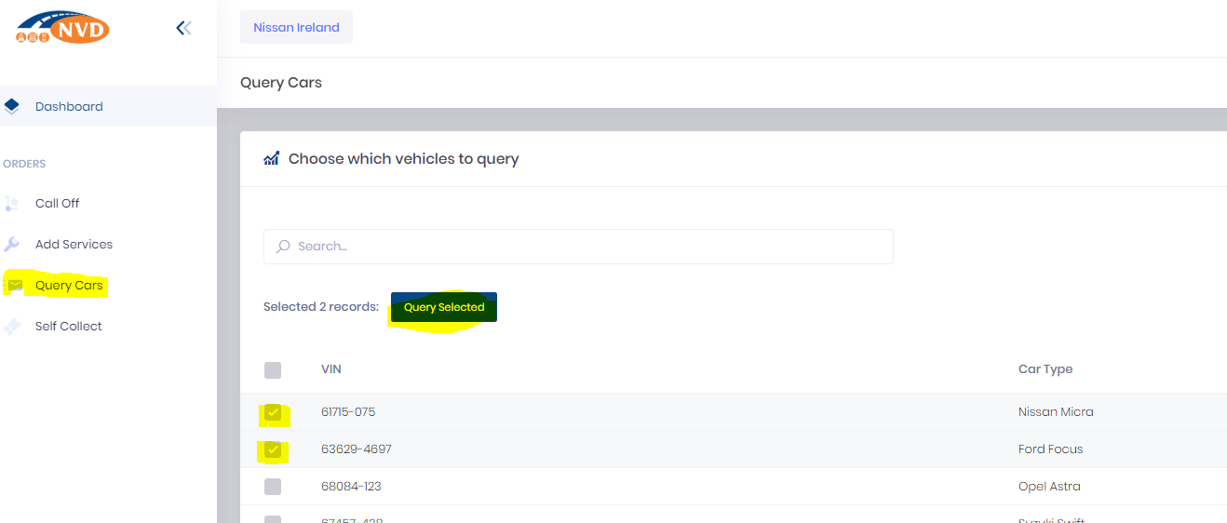

Arrange Self Collects

The Dealer Tracking App allows you as the dealer to arrange dealer self collects at pre agreed times.
Please be aware that collection slots are limited and are on a first come first serve basis.
To arrange click “Self-Collect” from the dashboard view.
Select the vehicle you wish to arrange collection of and click “Schedule Collection of Selected”
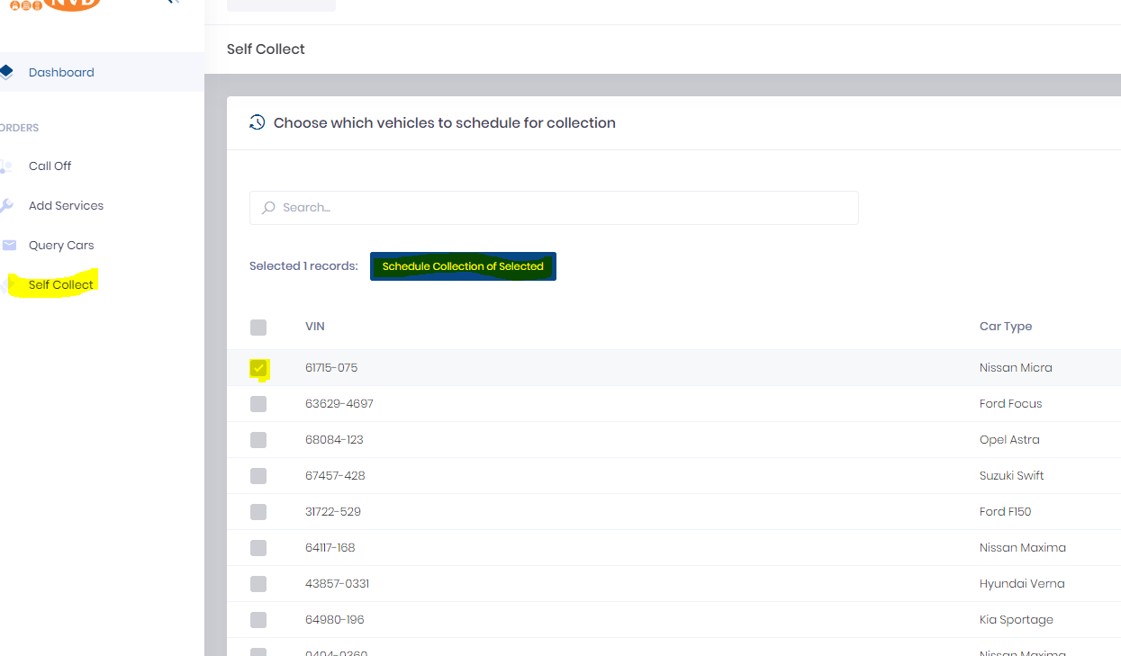
Select Date & Time
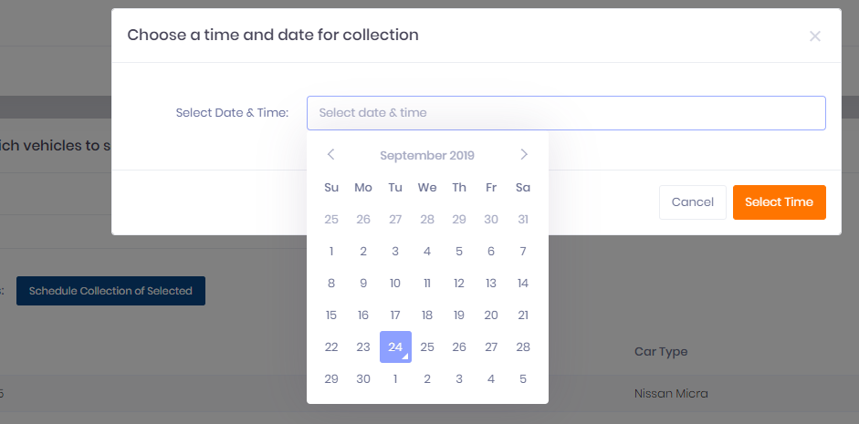

Add Services

Order services via the Dealer Tracking App.

One Vehicle

From the dashboard click the “+” icon.
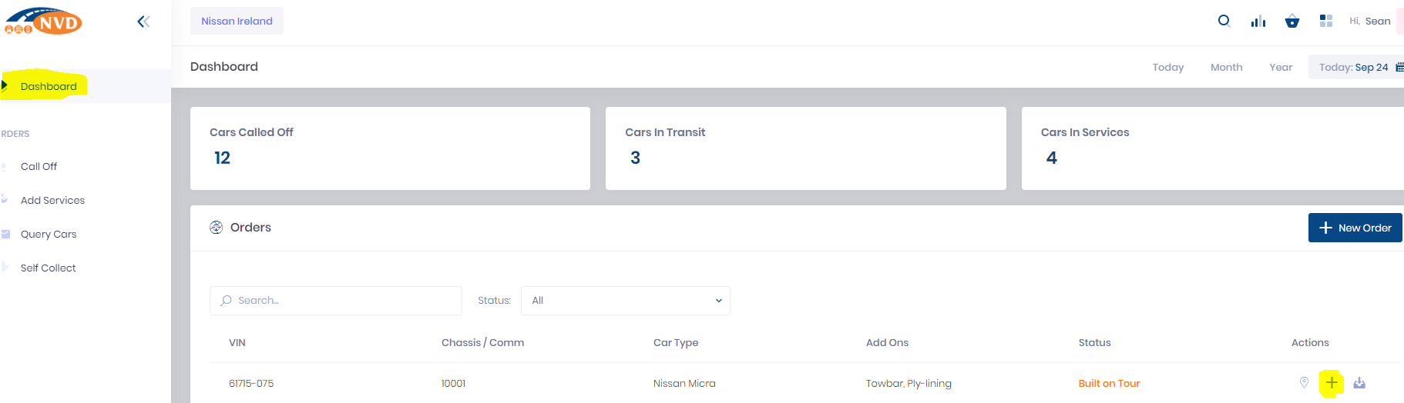

Select the service and click “add service.
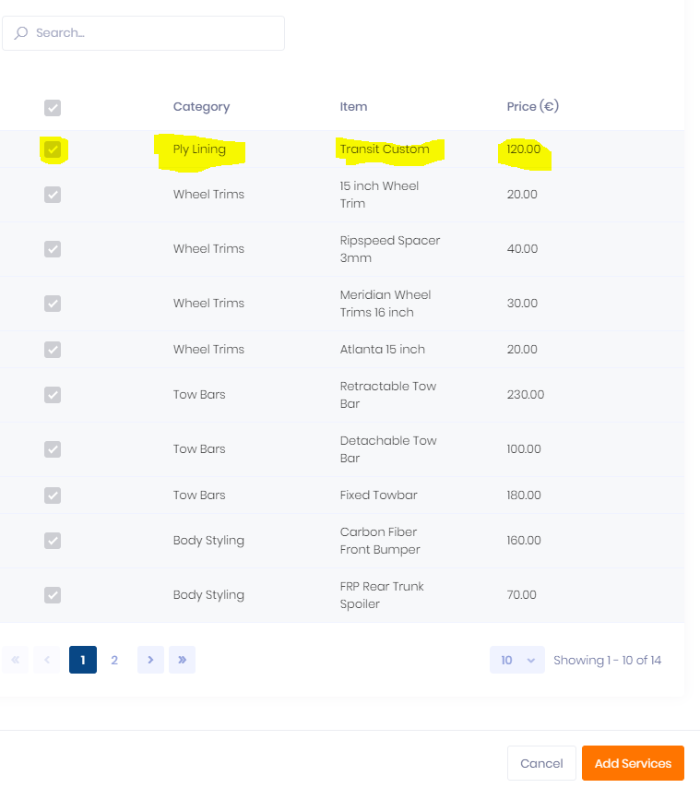

Proceed to payment.
Note – if you are set up on Direct Debit with NVD the charge will be taken via this method. If you are not you will be prompted to enter credit card detail as payment is required before the service(‘s) are completed.

Order service in batch

The app also allows you to order services for numerous vehicles at the same time.
Click “Add Services” on the dashboard and select the vehicle which you wish to add a service to.
Select the service you wish to have added.
Follow the above process for payment.

